**SQL Database**

**Amazon Books Summaries**

**1. Create a db in SQL about Amazon Dataset**

Create New Amazon Database using tasks and Import Excel File into SQL:

**2. Categorize the 550 books to fiction and non-fiction**

Dataset contained duplicate books so I created a query using common table expression (CTE) to assign a row number to each row using Row_number, Partition by and delete duplicate rows:

**Selected top 550 rows:**

**Run a query to categorize the books to fiction and non-fiction:**

**3. Query the top 50 best sellers and show the following:**

1. **Title of Book**
2. **Author**
3. **Year**
4. **Review**

**4. Query the books which have a rating greater than 4 released last in 2019:**

**5. Query the books which have greater than 10k reviews last 2018:**

**6. Query the books which are in the bottom 50 by Reviews ordered by reviews in ascending order:**

**7. Query the books for average Price per Genre and sort in Average Price descending order:**

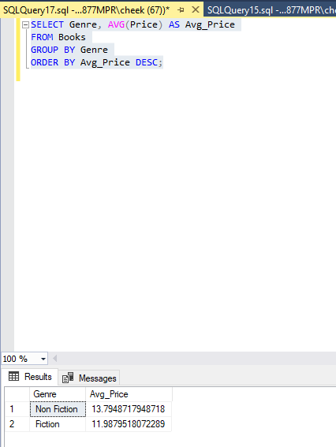

**8. Query the books which have the highest number of books per Author and order by descending order:**

**9. Select the top 3 Authors based on the Number of books written in the previous query:**

**10. Query the books written by Jeff Kinney which have reviews greater than 4k and ordered by Reviews descending:**

**11. Query the books written by Jeff Kinney which have Average Price and ordered by Average Price descending:**

**12. Query the books written by Jeff Kinney which have Average Year and is the book with the highest number of reviews. Ordered by Average Year Ascending:**

**13. Query the books written by Rick Riordan which have reviews greater than 2k and ordered by Reviews descending:**

**14. Query the books written by Rick Riordan which have Average Price and ordered by Average Price descending:**

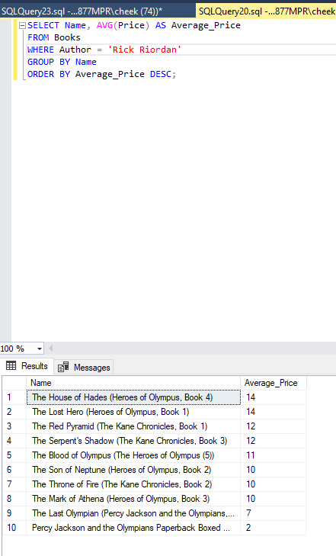

**15. Query the books written by Rick Riordan which have Average Year and is the book with the highest number of reviews. Ordered by Average Year Ascending:**

**16. Query the books written by Stephenie Meyer which have reviews greater than 5k and ordered by Reviews descending:**

**17. Query the books written by Stephenie Meyer which have Average Price and ordered by Average Price descending:**

**18. Query the books written by Stephenie Meyer which have reviews greater than 4k and ordered by Reviews descending:**

**19. Query the books written by Jeff Kinney, Rick Riordan and Stephanie Meyer which have booked released at the latest year and ordered by latest Year Reviews descending:**

**20. Query the books written by Jeff Kinney, Rick Riordan and Stephanie Meyer which have average price and ordered by average ascending:**

**21. Query the books published by each since the year 2000, where the author has published more than 5 books. The results will be ordered in descending order of the number of books:**

**22. Query the books name, author, average user rating, total number of reviews, average price and year.** **The results will be grouped by name, author, year and genre and ordered in descending order of the average user rating.:**

**23. Query the books first calculate the average user rating and total number of reviews for each author and then select the top 5 authors based on their average user rating and total number of reviews.**

**The final query returns the name, author, user rating, number of reviews, price, year and genre for books written by the top 5 authors. The results are ordered by author and year in descending order:**

**24. Query the books first calculate the average user rating and total number of reviews for each genre and then select the top 3 genres based on their average user rating and total number of reviews.**

**The final query returns the name, author, user rating, number of reviews, price, year and genre for books in the top 3 genres. The results are ordered by genre and year in descending order.:**

**25. Query the books first calculate the average user rating and total number of reviews for each author and then select the top 5 authors based on their average user rating and total number of reviews. The next calculates the number of books for each genre for the top 5 authors. Then rank the genres for each author based on the number of books and then select the top genre for each author.**

**The final query returns the name, author, user rating, number of reviews, price, year and genre for books in the top genres for the top 5 authors. The results are ordered by genre and year in descending order.**

